Reaction Rates

Select the alternative that correctly answers the following questions.

The next two questions refer to the information below.

In the extraction of iron in the blast furnace, a mixture of iron ore, coke (form of carbon) and limestone is used.
The overall reaction is:
Fe₂O₃(s) + 3CO(g)  2Fe(s) + 3CO₂(g)

1. What is the function of the limestone in the extraction process?

a) It acts as a catalyst in the reaction.
b) Its decomposition at high temperatures provides the calcium oxide and carbon dioxide needed for the extraction process.
c) It forms a layer of slag over the iron to prevent its oxidation.
d) It acts as an insulator of heat.

2. With reference to the above equation, which of the following statements is true?

a) The carbon monoxide acts as a reducing agent.
b) The iron (II) oxide is oxidised in the reaction.
c) The oxidation state of the iron has changed from +2 to 0.
d) The carbon monoxide is reduced in the reaction.

A student wishes to determine the order of reactivity of five metals A, B, C, D and E.
The results of his experiments are summarised in the table below:

METALS
 | A | B | C | D | E
Reaction with cold water. | Reacts slowly | N.R. | N.R. | Vigorous | N.R.
Reaction with steam on B, C and D. |  | N.R. | Reacts |  | Reacts
Reaction with HCl acid. | Vigourous | N.R. | Reacts | Vigourous | Reacts
Adding of a solution containing ions of metal E | A displaces E from solution. | N.R. | C displaces E from solution | D displaces E from solution.

3. The correct order of the metals from most reactive to least reactive is

a) D, A, E, C, B. b) D, A, C. E, B.
c) D, A, B, C, E. d) D, A, C, B, E.

4. Metal D could be which one of the following:

a) Sodium.
b) Magnesium.
c) Aluminium.
d) Zinc.
e) Iron.

5. Metal B could be which one of the following:

a) Magnesium.
b) Aluminium.
c) Iron.
d) Copper

6. Which metal is most likely to be calcium?

a) Metal A.
b) Metal B.
c) Metal C.
d) Metal D.
e) Metal E.

7. Which one of the following would NOT cause an increase in the RATE of a chemical reaction?

a) Addition of a catalyst.
b) Increasing the concentration of the reactants.
c) Decreasing the temperature of the reacting species.
d) Increasing the pressure of gases involved in a reaction.

8. Consider the reaction between marble chips (calcium carbonate) and dilute hydrochloric acid:
CaCO₃(s) + 2H⁺(aq)  Ca²⁺(aq) + CO₂(g) + H₂O(l)

Which one of the following would increase the rate at which the marble chips react?

a) Decreasing the concentration of the hydrochloric acid.
b) Adding more water to the solution.
c) Crushing the marble chips into powder form.
d) Decreasing the temperature of the acid solution added.

9. The decomposition of hydrogen peroxide into oxygen and water proceeds very slowly at room temperature. However, the addition of a small amount of manganese dioxide (MnO₂), causes the hydrogen peroxide to bubble vigourously due to the rapid production of oxygen.

2H₂O₂(aq) O₂(g) + 2H₂O(l) very slow

2H₂O₂(aq) 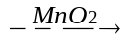 O₂(g) + 2H₂O(l) vigorous

The best explanation for this is

a) The manganese dioxide acts as a catalyst, providing an alternative reaction pathway that has a lower activation energy.
b) The manganese dioxide increases the temperature of the reaction thereby increasing the collision rate of the molecules.
c) The manganese dioxide increases the collision rate between reacting molecules simply by causing an increase in the total number of molecules in the solution.
d) The manganese dioxide increases the collision energy of the hydrogen peroxide molecules

10. The equation for the reaction between hydrochloric acid and sodium thiosulfate can be represented as :

S₂O₃²⁻(aq) + 2H⁺(aq) H₂O(l) + SO₂(g) + S(s)

Which one of the following would NOT increase the rate of this reaction?

a) Increasing the temperature of the reacting solutions.
b) Increasing the concentration of sodium thiosulfate.
c) Increasing the concentration of the hydrochloric acid used.
d) Increasing the air pressure around the reaction vessel.

11. The equation for the reaction between calcium carbonate and hydrochloric acid is shown below.

CaCO₃(s) + 2HCl(aq) CaCl₂(aq) + CO₂(g) + H₂O(l)

Which one of the following would NOT increase the rate of this reaction?

a) Increasing the concentration of the hydrochloric acid.
b) Raising the temperature of the acid solution.
c) Using the calcium carbonate in a finer state.
d) Adding more water to the reaction.

The next three questions refer to the information below.

An experiment was performed to measure the amount of oxygen gas evolved at ten second intervals, when 40 mL of hydrogen peroxide was allowed to decompose according to the equation:
_{MnO2}
2H₂O₂(l) 2H₂O (l) + O₂(g)

The reaction was carried out at 20ºC and 0.5 g of manganese dioxide added at the start of the experiment. The results are shown in the graph below.

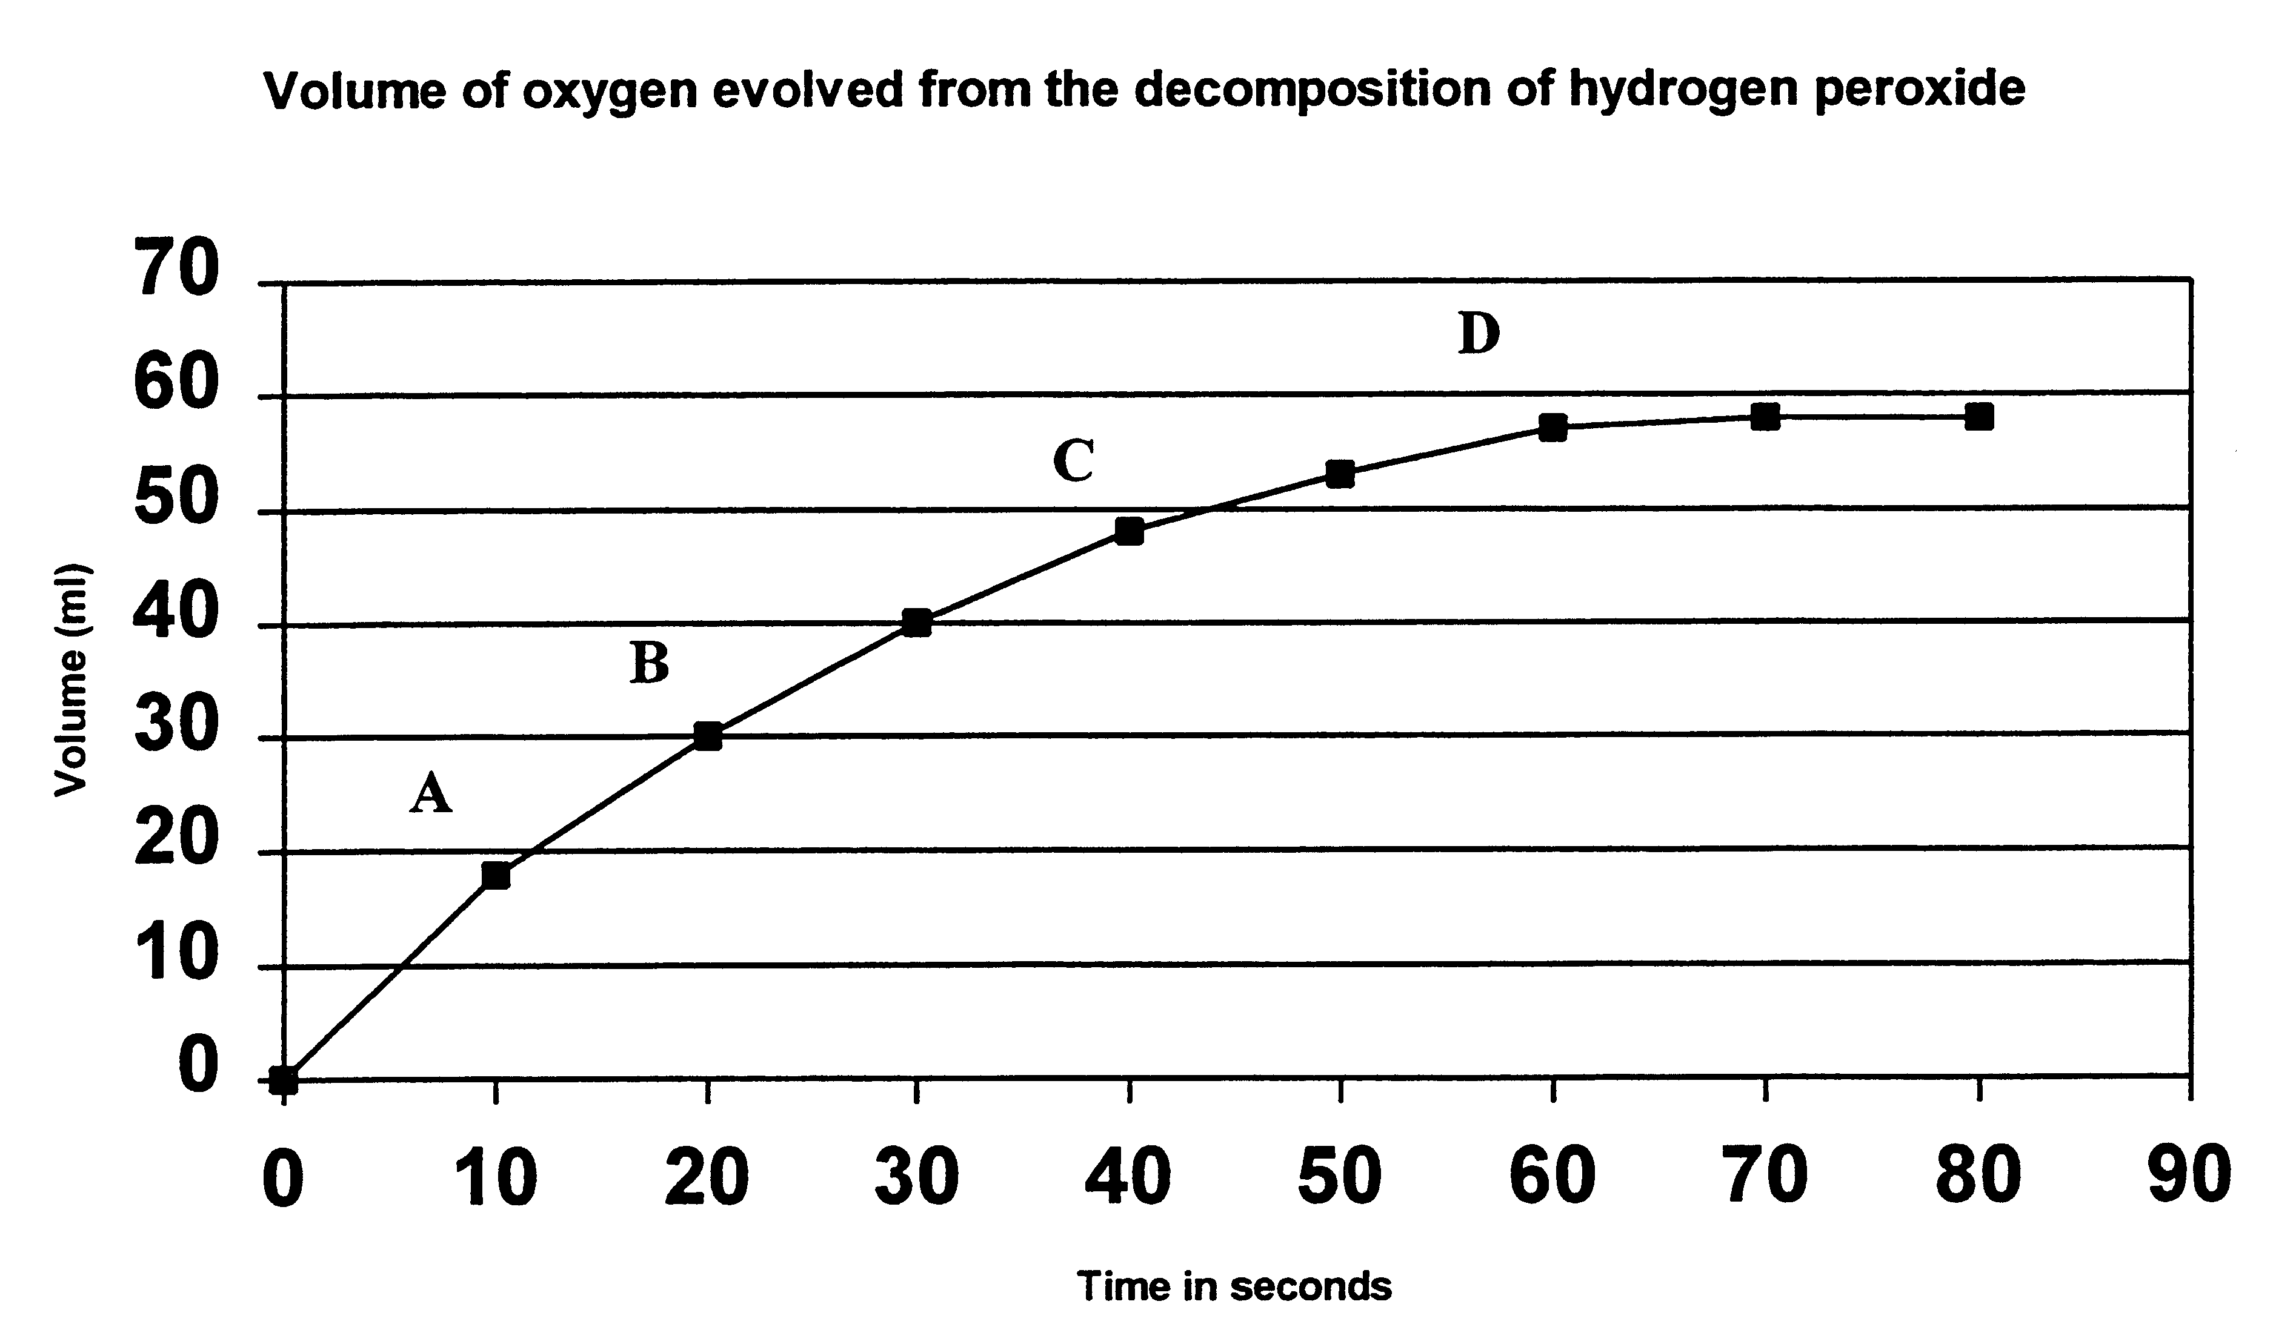

12. At what interval is the RATE of reaction greatest?

a) Between 0 and A.
b) Between A and B.
c) Between B and C.
d) Between C and D.

13. The manganese dioxide acts as a catalyst and increases the rate of decomposition of hydrogen peroxide. How is it thought to do this?

a) By lowering the activation energy of the reaction.
b) By increasing the energies of hydrogen peroxide molecules, thus increasing the frequency of successful collisions between them.
c) By decreasing the rate of collisions between the product molecules, thereby decreasing the rate of the reverse reaction.
d) Both (c) and (d) above.
14. If the hydrogen peroxide was heated to 80ºC and then the manganese dioxide added, which of the graphs below would show the expected results?

